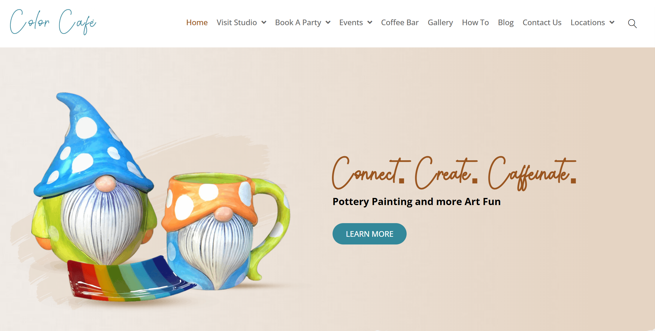

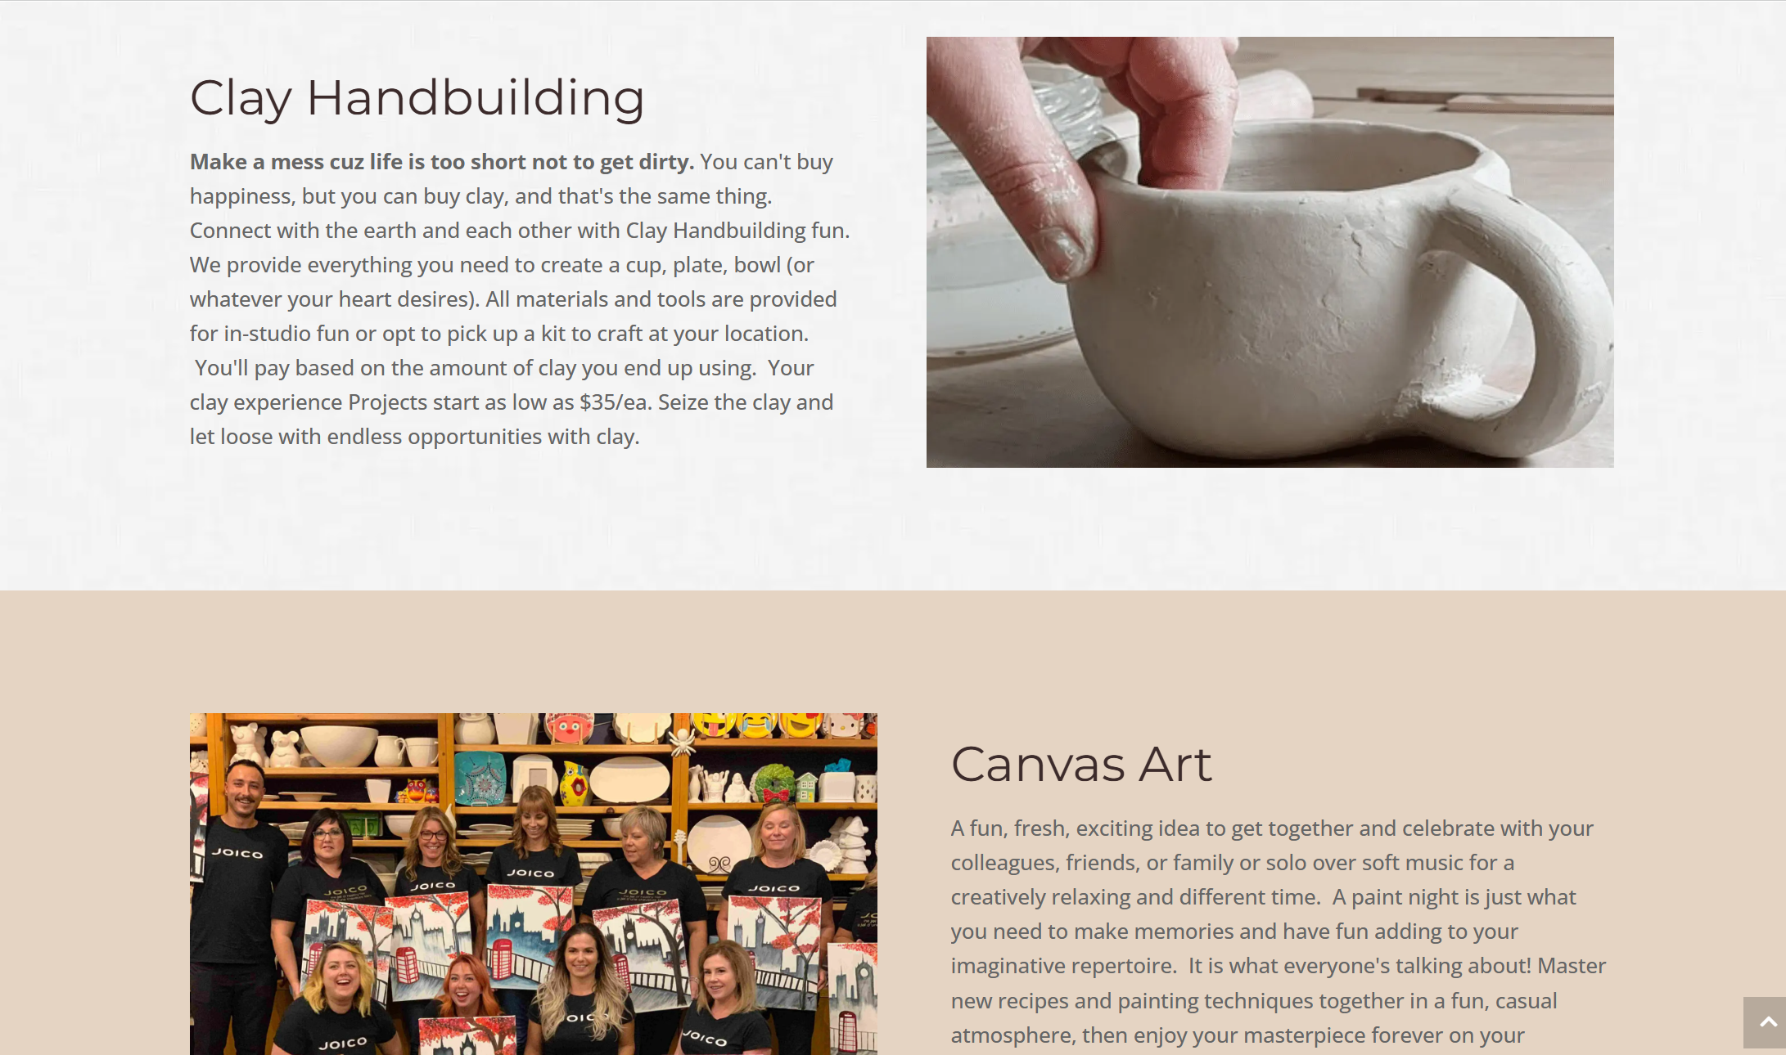

The art studio and cafe that I chose to review the website of is Color Café. Their website can be found at <https://colorcafe.ca/>. Users can view available art activities such as Pottery Painting, Glass Fusion, Clay Hand building, and Canvas Art, and then purchase reservations for studio sessions in advance at either of their Calgary or Edmonton locations. This is very helpful for a lot of people as they can plan creative date nights, celebrations, or self-care time in advance, especially for booking the popular Pottery Wheel workshops. Another feature of this site is the ability to book private parties and group events, and they also provide details on their "Take & Make Kits" for those who prefer to create at home.

**Presentation**

My first impression of the site was warm, inviting, and cheerful. The design uses bright, energetic colors (yellow, pink, teal accents) and high-quality photographs of people enjoying themselves, aligning with its fun art concept.

The first thing I looked at was the prominent hero image and headline section: "Connect. Create. Caffeinate. Pottery Painting and more Art Fun." This instantly defines the company's value proposition that it's a social space, a creative studio, and a cafe. Immediately below this, I noticed the strong, contrasting ‘Learn More’ call-to-action button.

**Performance**

A sticky header/navigation bar at the top remains constant, featuring key links: Home, Visit Studio, Book A Party, Events, Coffee Bar, Gallery, How To, Blog, and Contact Us. The hierarchy is clear, prioritizing transactional actions ("Visit Studio," "Book A Party") alongside informational pages.

The navigation bar, header logo, and footer remain in the same position and use the same color scheme on both the Home page and the Coffee Bar Menu page. This high level of consistency aids usability and reinforces brand trust.

The links are highly accurate and specific. For example, clicking "Coffee Bar" correctly navigates to the dedicated menu page. Crucially, the "Visit Studio" and "Book A Party" links clearly present two location options (Calgary and Edmonton) before sending the user to the respective external booking platform, demonstrating thoughtful information architecture.

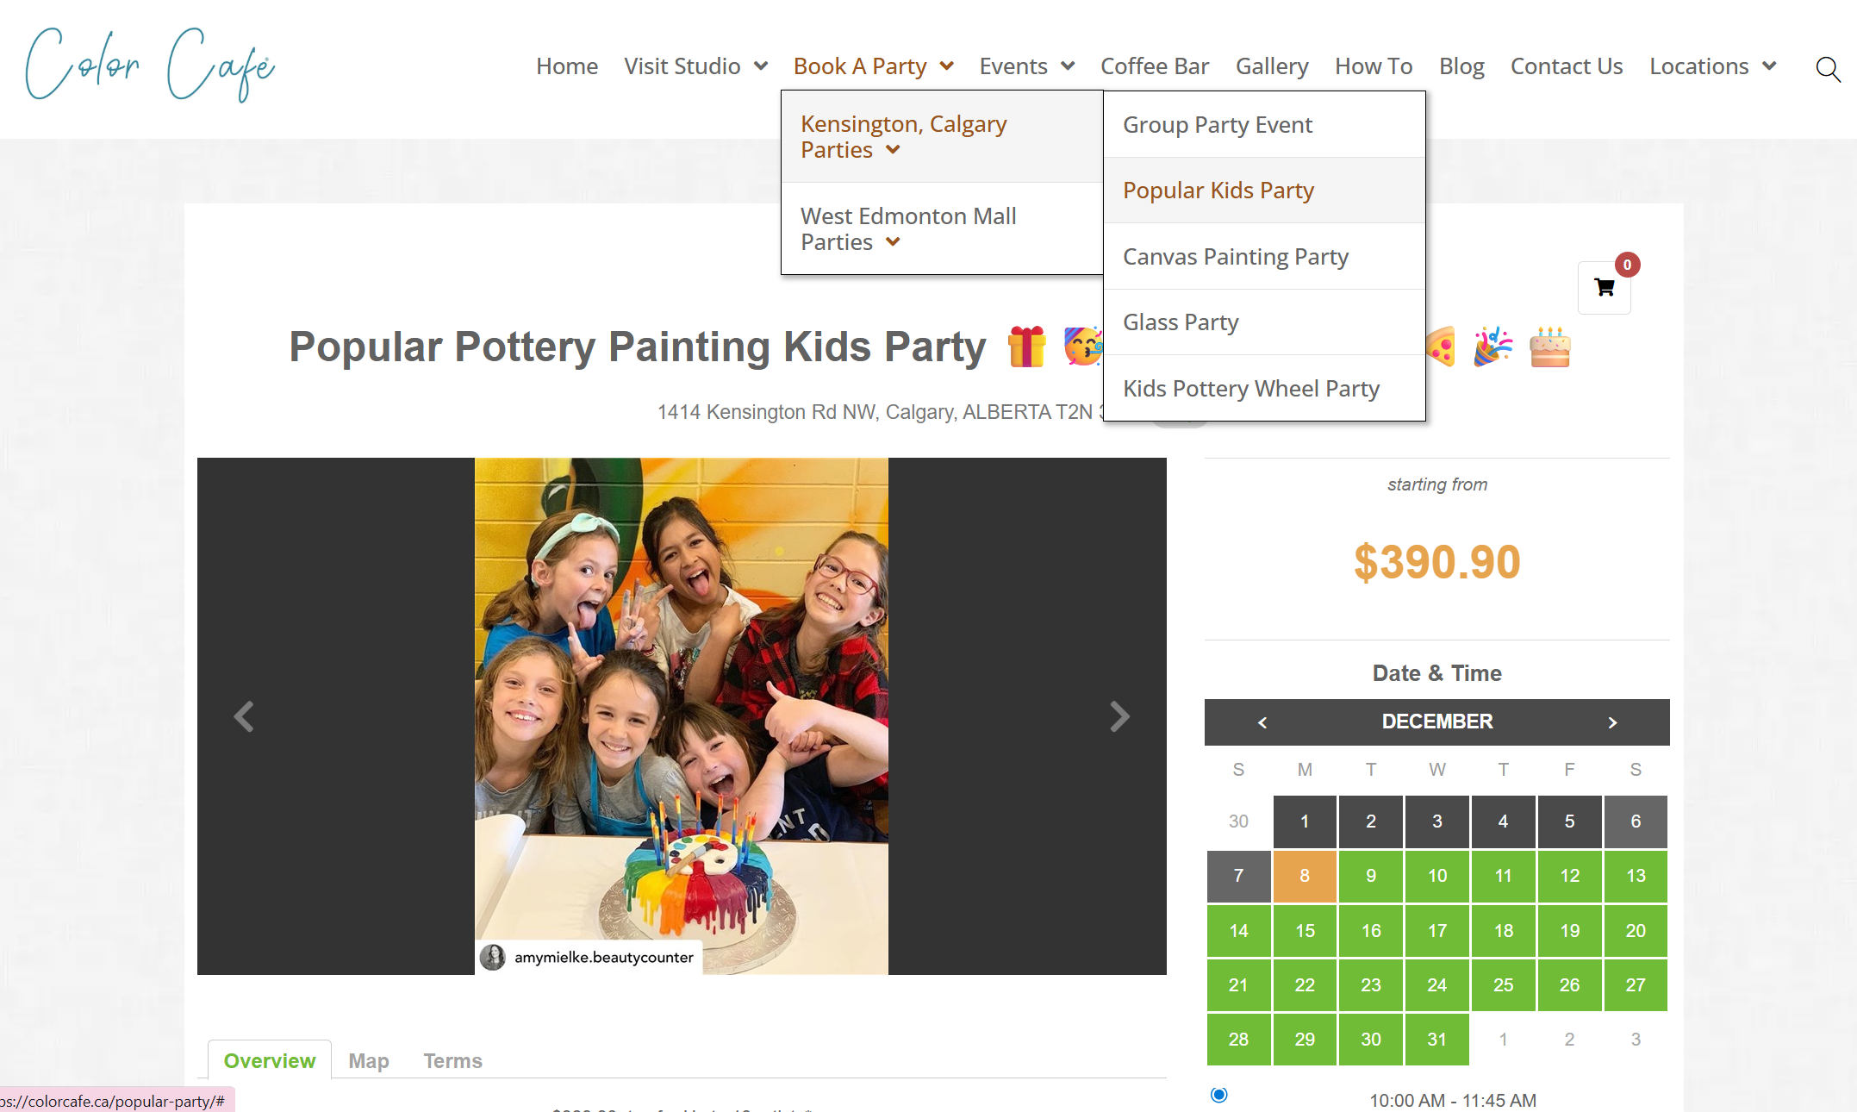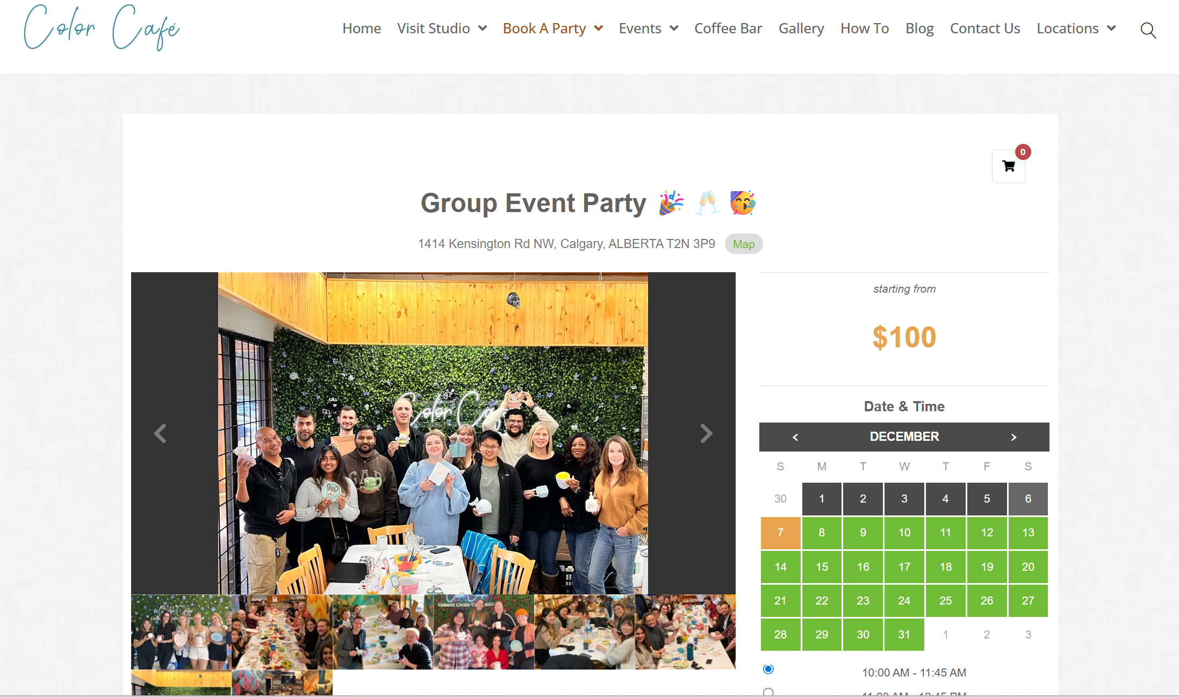

**Usability**

Usability is a **major strength**. The site is easy to navigate with a clear top-level menu (Home, Visit Studio, Book A Party, Events, etc.). Crucially, it immediately differentiates between the two locations (Calgary and Edmonton) for reservations and party bookings, minimizing confusion for users. The activities are described with clear processes (e.g., what happens after pottery painting) and general pricing ranges are provided, which helps users set expectations

**Strengths & Weaknesses**

The website's strengths lie in its visual appeal, clarity, and user-centric design:

The site uses vibrant, high-quality visuals and the memorable tagline "Connect. Create. Caffeinate." to immediately convey a fun, welcoming, and low-pressure atmosphere. The design is clean and professional, aligning perfectly with the business's creative and social goals.

The site intelligently manages its two locations (Calgary and Edmonton). Key transactional links (Reservations, Book A Party) immediately prompt the user to select a specific city, preventing booking errors and drastically improving the user journey.

The content clearly and concisely explains all the art activities, including pricing ranges, what the session includes (paints, firing), and crucial details like the ability for customers to return multiple times at no extra charge to finish a project. This transparency reduces friction for first-time visitors.

Clear Calls-to-Action - The primary CTAs, especially those leading to reservations, are well-placed, highly visible, and functional.

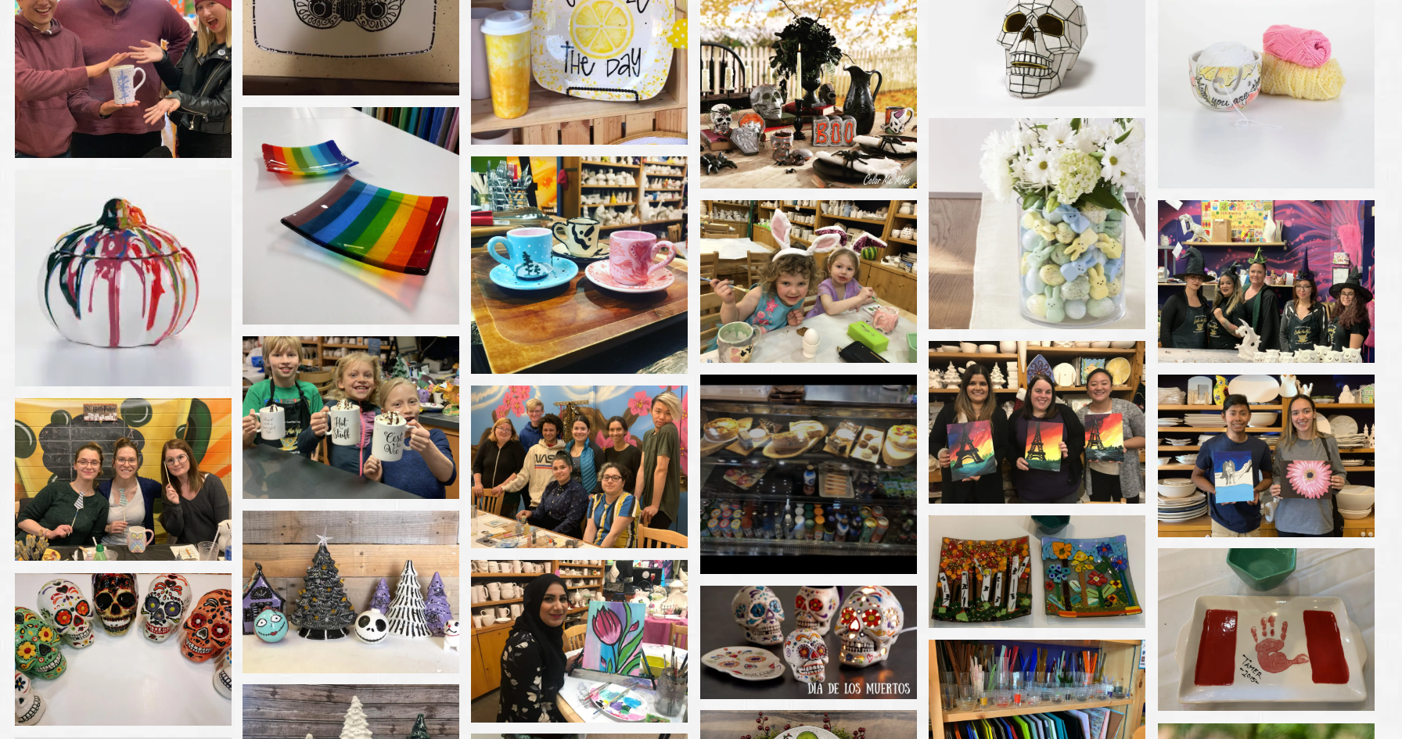

The weaknesses primarily involve:

General Pricing Transparency: The site only provides broad price ranges (e.g., $40–$80 average) for pottery pieces. The lack of a categorized gallery or price list for the 1000+ ceramic items mean budget-conscious users must commit to visiting the studio without knowing the exact cost of the piece they may choose.

Minor UX/UI Inconsistencies: Small issues, such as the hero banner's "Learn More" button only scrolling down the page instead of linking to a dedicated page, or minor visual alignment inconsistencies in the footer, create a less polished feel.

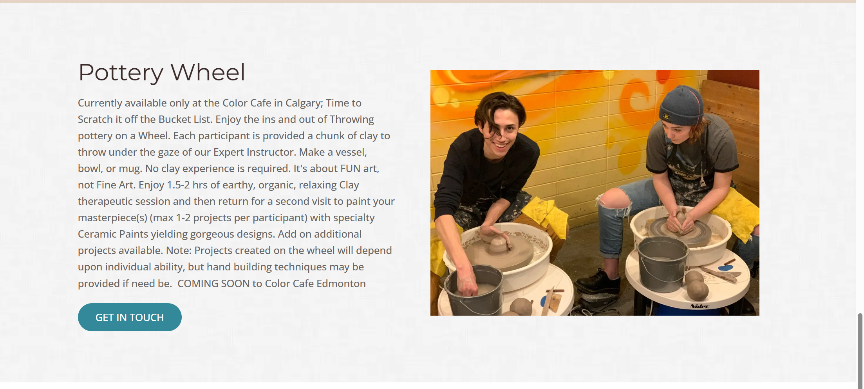

Overall, I believe that the website is excellent. The few weaknesses it did have namely the lack of specific pottery piece prices were more focused on depth of information rather than fundamental design or functional flaws. I don't think there would be many people who would complain about the design, features, or most importantly, the outstanding ease of booking offered by this website. It succeeds completely at its primary goal of being a fun, inviting, and reliable tool for planning a creative outing.